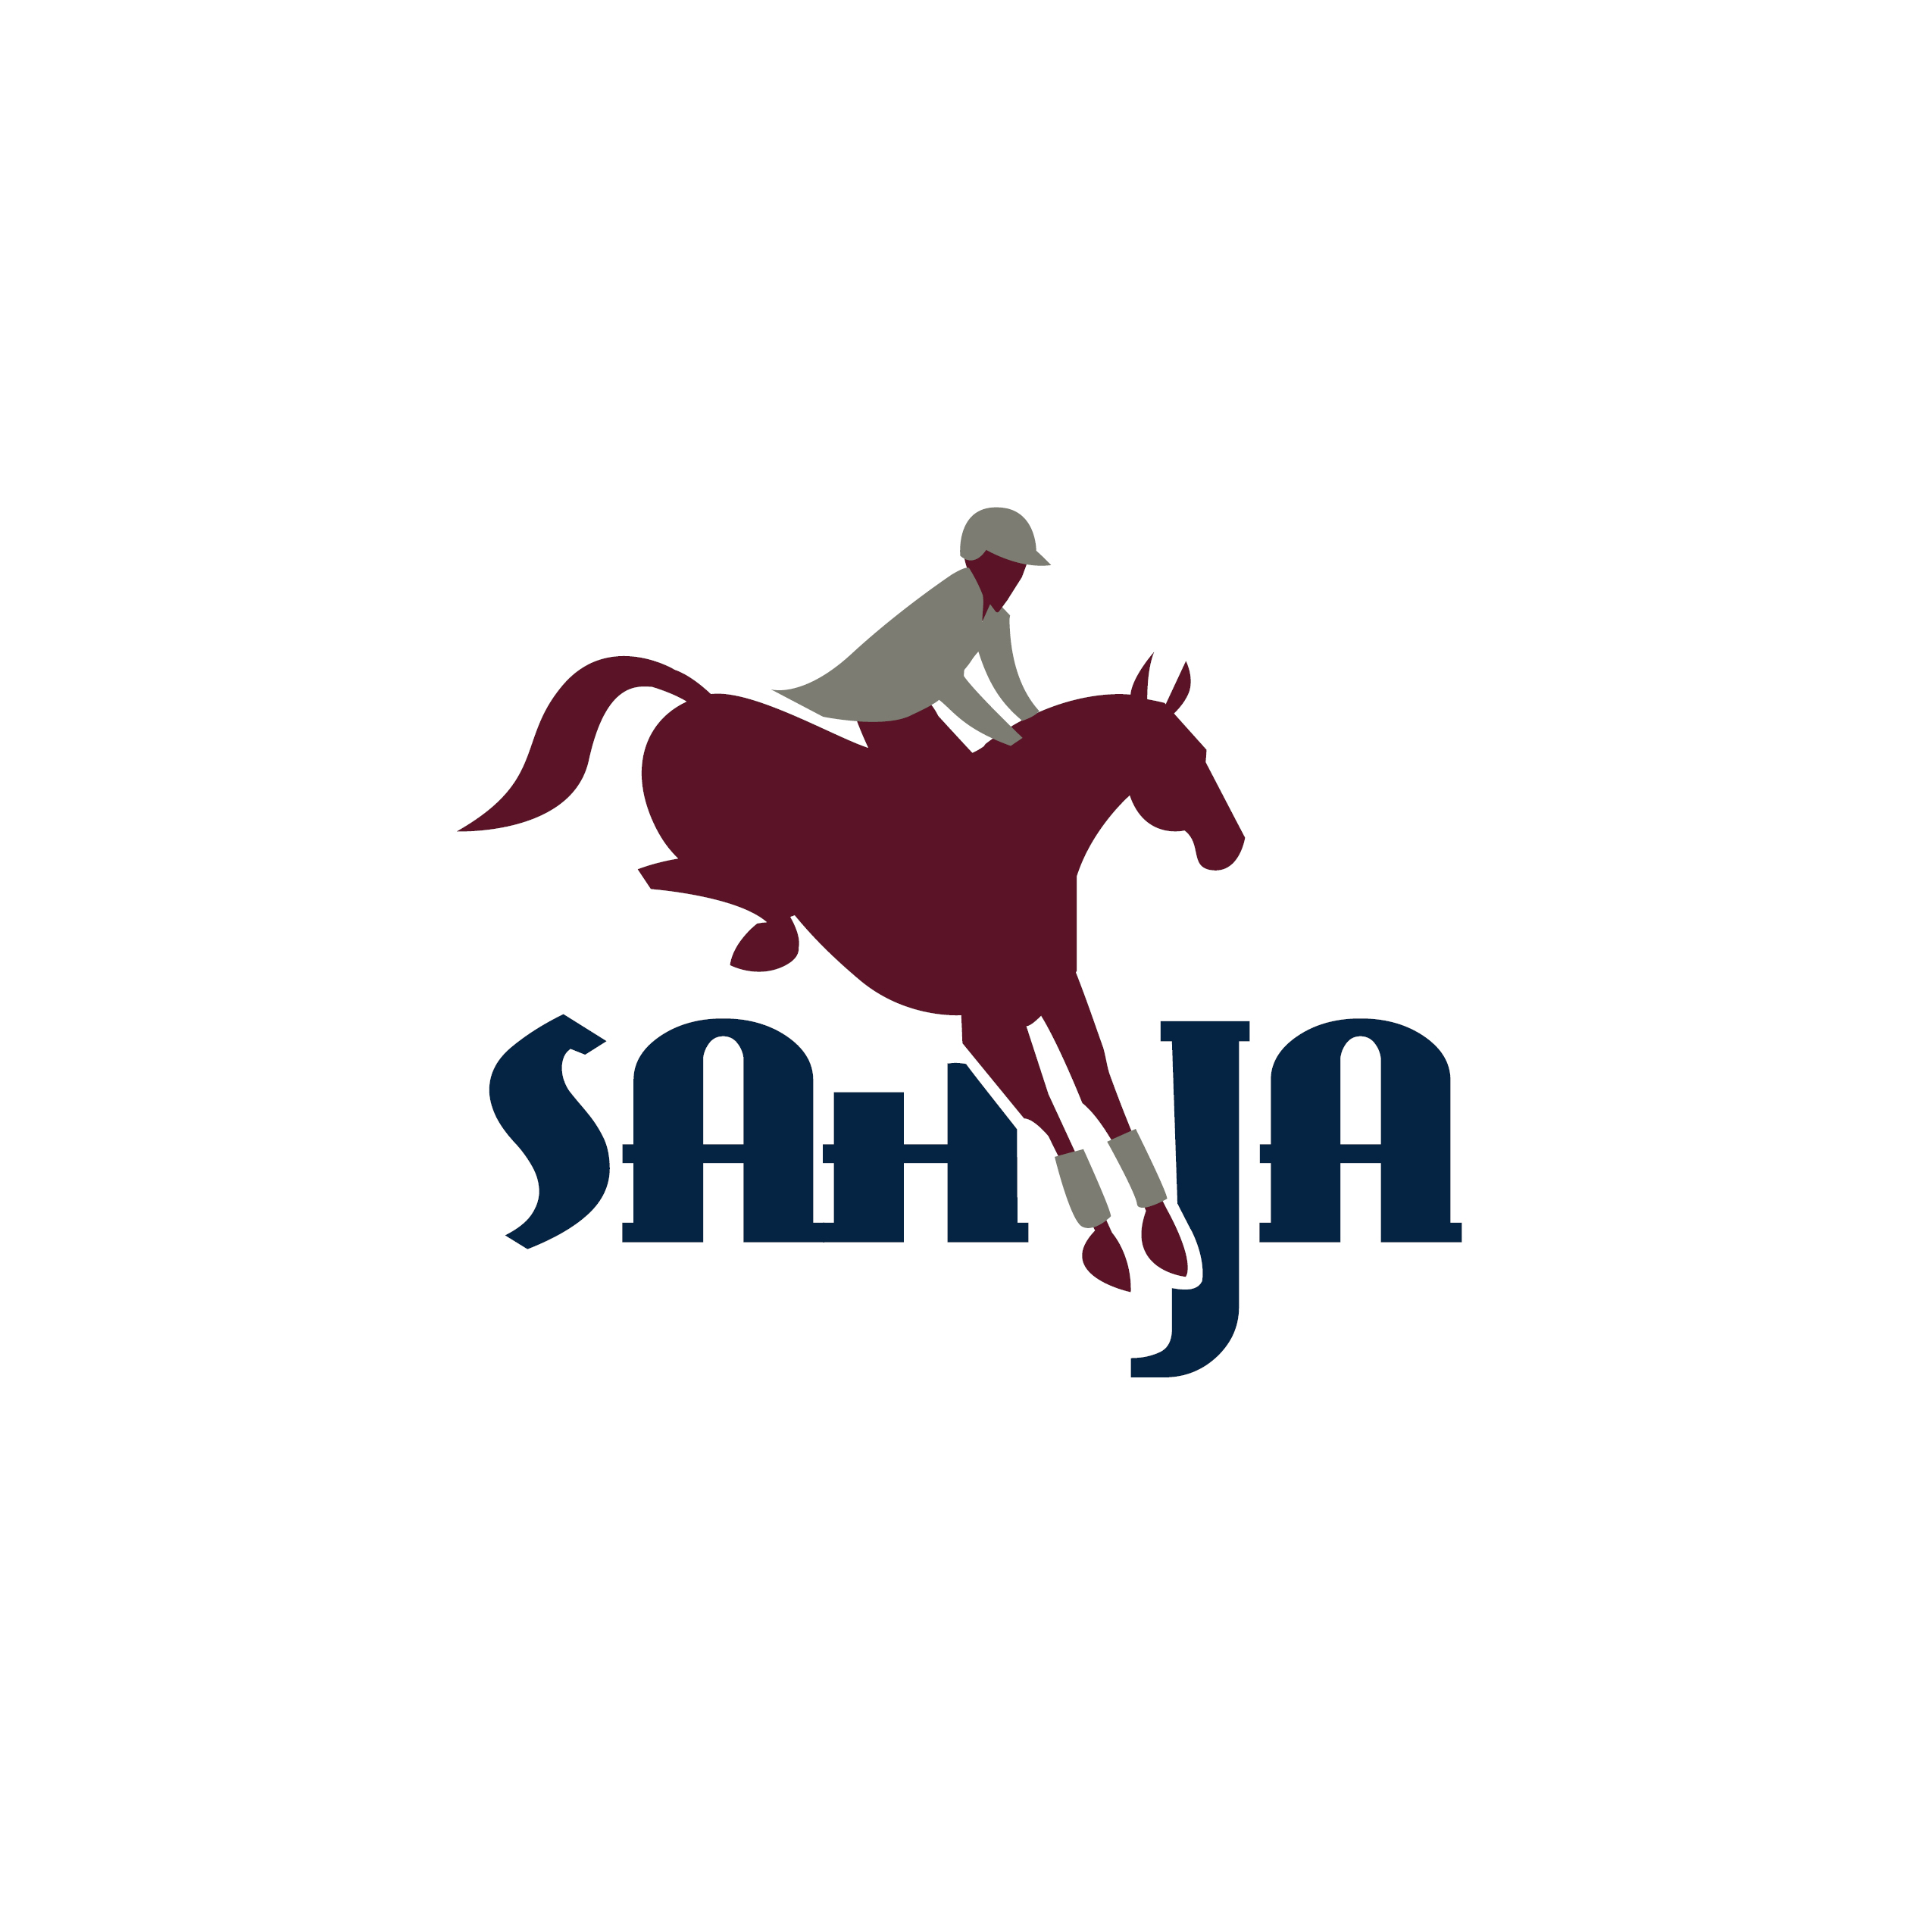

September 23 & 24, 2017
Brookside’s Back to School

Entry fee: $140 per team ($35 per team member, includes both rounds)
Riders must be current members of SAHJA in good standing. Open only to junior and amateur riders.
Entries limited to 10 teams, first come, first serve by date received.

Jumper teams of max four (minimum three) compete in a two round format with the first round of competition a speed round, and the second an Argentine Jumper round. Riders will show at three levels: 2’3”, 2’6”-2’9”, and 3’-3’3”. Teams must have one rider at each level, and the final rider may choose the level at which they compete. Three scores per team, per round will count. The highest score per round will be dropped. The first round is on Saturday evening, second round on Sunday morning.

A rider sash, coordinated Hunt coats, saddle pads and horse leg wear are suggested, but not mandatory. (Sash provided at the show).

The winning team will have their names engraved on the Grebitus Challenge Cup, generously sponsored by Grebitus and Sons Jewelers, and it will be displayed at the business. Each team member will receive an award to keep at the 2017 SAHJA Awards Banquet and ribbons for the first ten teams.

Please send the declaration form below to attn.: Lorraine Kemper @ Brookside
11120 Bradley Ranch Road
Elk Grove, CA 95624
or scan and email to brooksideshowparkinfo@gmail.comby September 15, 2017.
Any questions contact Lorraine at (916) 682-1403.

Team Name:______________________________________________________

Chef d-equipe:____________________________________________________ Height Declared

1. ________________________________________________________________________ ___________________

2. ________________________________________________________________________ ___________________

3. ________________________________________________________________________ ___________________

4. ________________________________________________________________________ ___________________

